**Lab # 08**

**OBJECT**

***Configure Dual Stacking in IPv6***

**TOPOLOGY:**

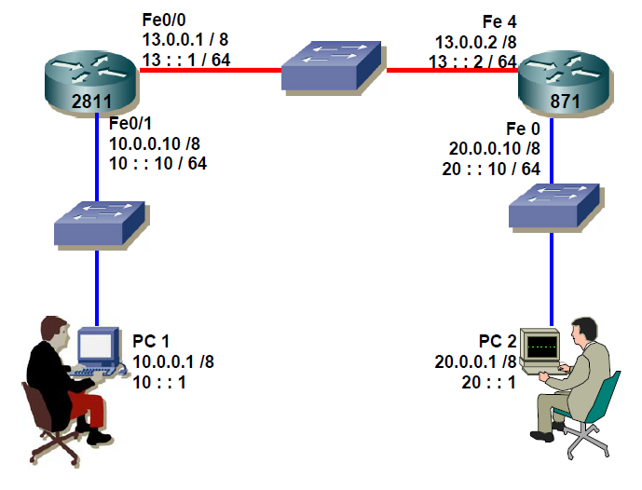

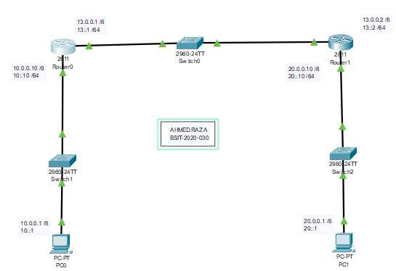

**LAB TASK:**

**Part 1: Assign IPv4 Addresses as shown in figure**

**ROUTER 0:**

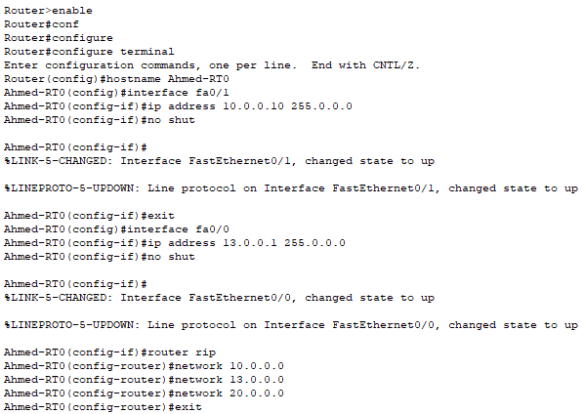

**ROUTER 1:**

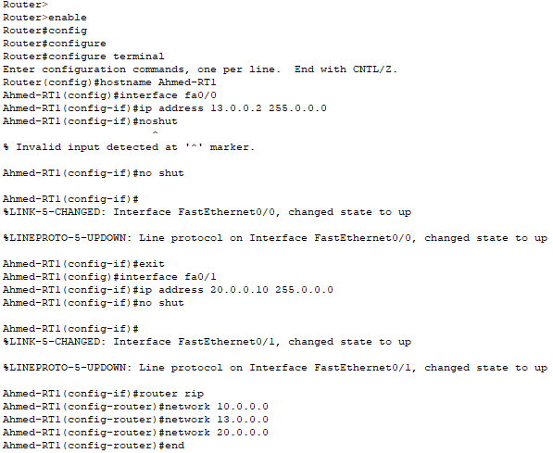

**Part 2: Assign IPv6 Addresses as shown in figure**

**ROUTER 0:**

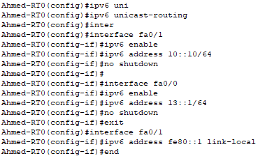

**ROUTER 1:**

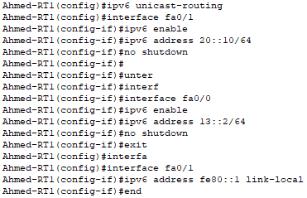

**Part 3: Configure IPv6 Static Route**

**ROUTER 0:**



**ROUTER 1:**



1. What is the difference between link-local and unique local IPv6 Address?

A: Link local addresses are used in one single network segment; they can't be routed. Unique local addresses can be routed, but only within one routing domain. So, an ISP can choose to use ULA for services which can't be publicly accessible.

2. Verify end to end connectivity by pinging from PC 1 to PC 2 attach the

screenshot.

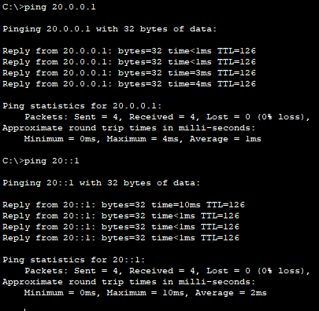

3. Which command would be use to display IPv6 routing table?

